**Week 10**

Q1)

Given a string, s, consisting of alphabets and digits, find the frequency of each digit in the

given string.

Input Format   
The first line contains a string, num which is the given number.

Constraints

1 ≤ len(num) ≤ 1000

All the elements of num are made of English alphabets and digits.

Output Format

Print ten space-separated integers in a single line denoting the frequency of each digit

from 0 to 9.

Sample Input 0   
a11472o5t6

Sample Output 0   
0 2 1 0 1 1 1 1 0 0

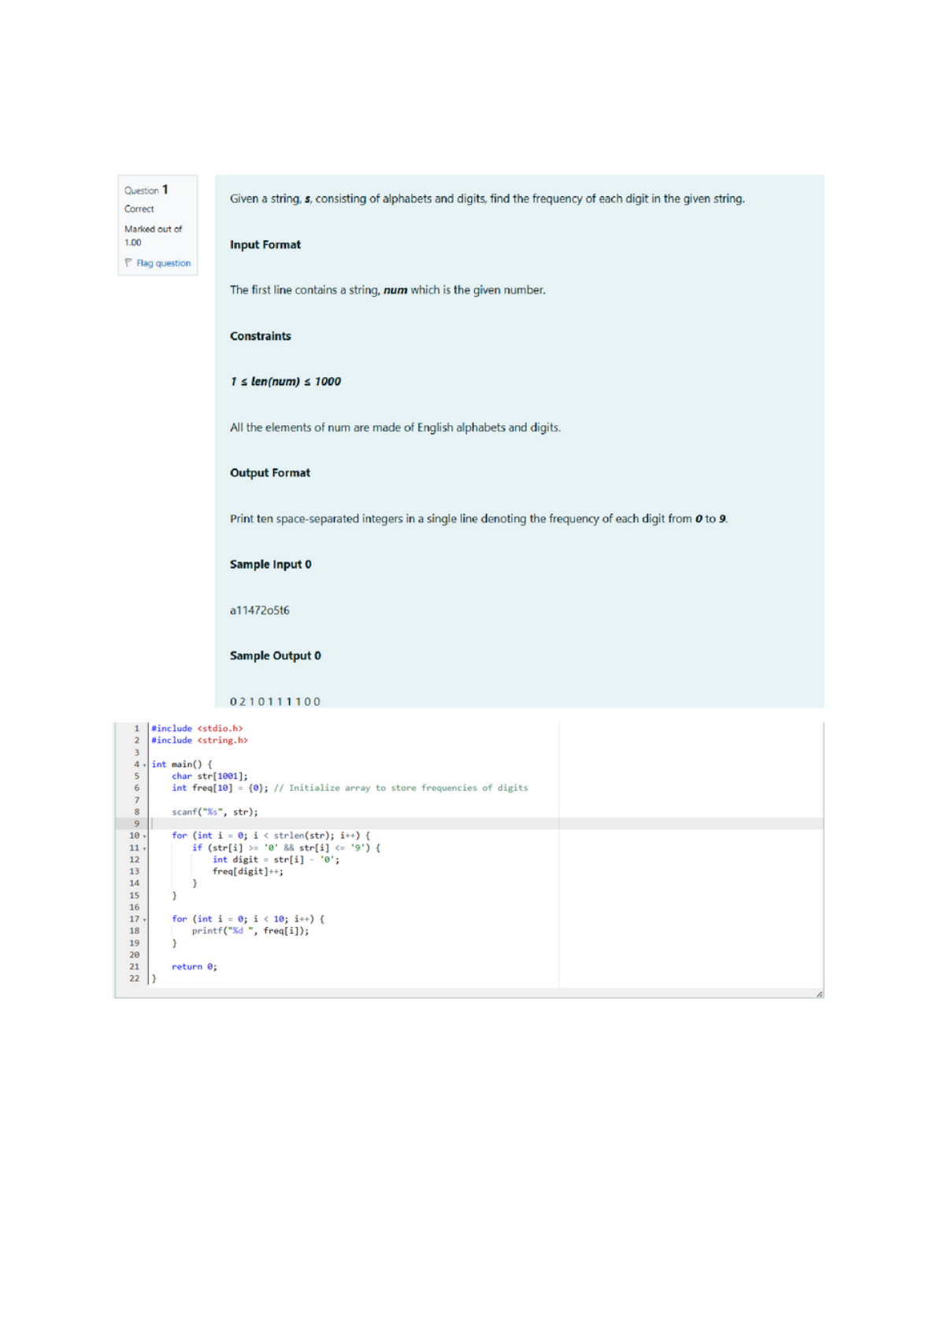

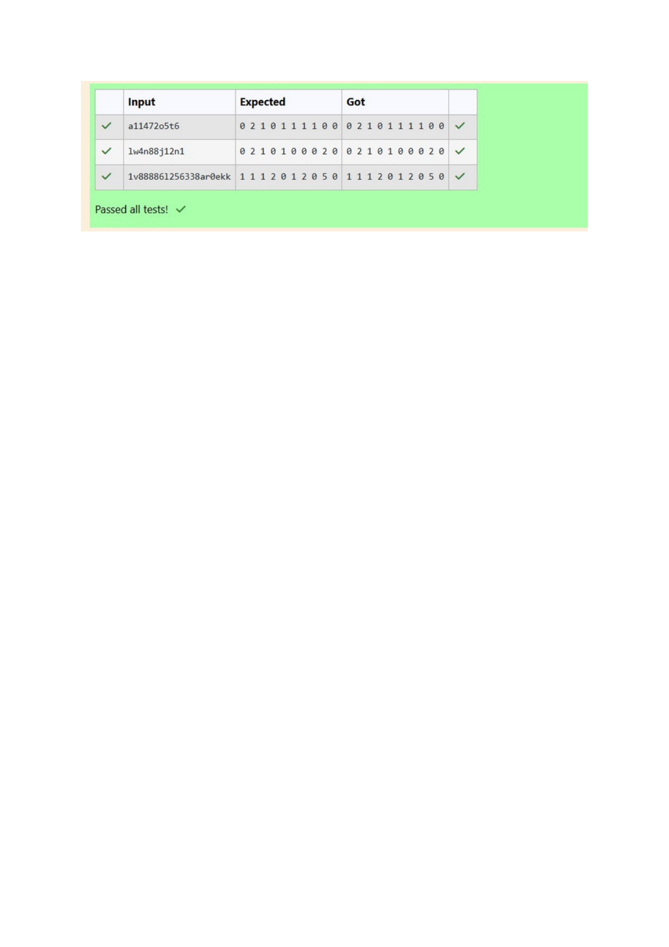

Q2) Today, Monk went for a walk in a garden. There are many trees in the garden and each

tree has an English alphabet on it. While Monk was walking, he noticed that all trees with

vowels on it are not in good state. He decided to take care of them. So, he asked you to tell

him the count of such trees in the garden.

Note: The following letters are vowels: 'A', 'E', 'I', 'O', 'U', 'a', 'e', 'i', 'o' and 'u'.

Input Format:

The first line consists of an integer T denoting the number of test cases.

Each test case consists of only one string, each character of string denoting the alphabet

(may be lowercase or uppercase) on a tree in the garden.

Output Format:

For each test case, print the count in a new line.

Constraints:

1 ≤ T ≤ 10

1 ≤ length of string ≤ 105

Sample Input

2

nBBZLaosnm

JHkIsnZtTL

Sample Output

2

1

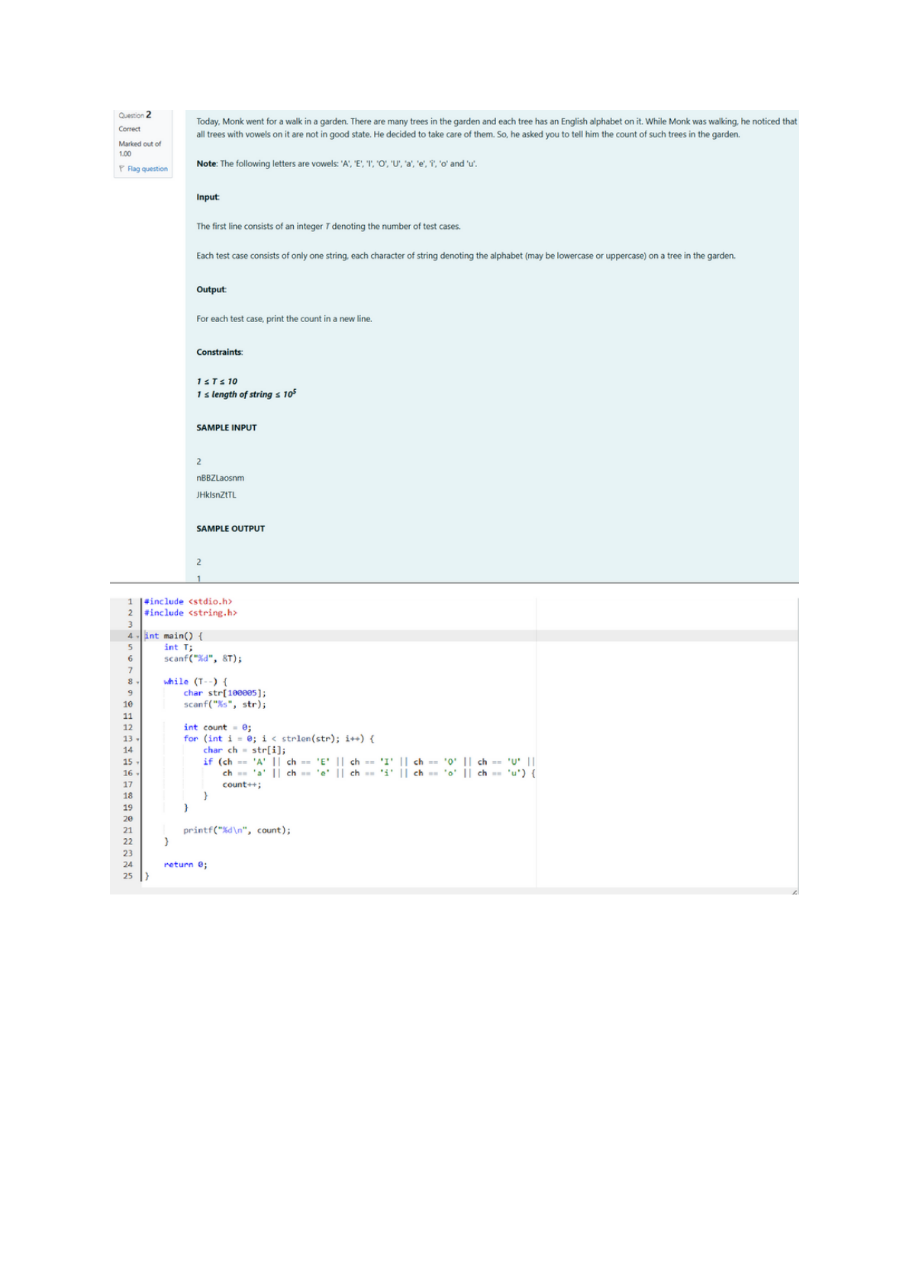

Output:

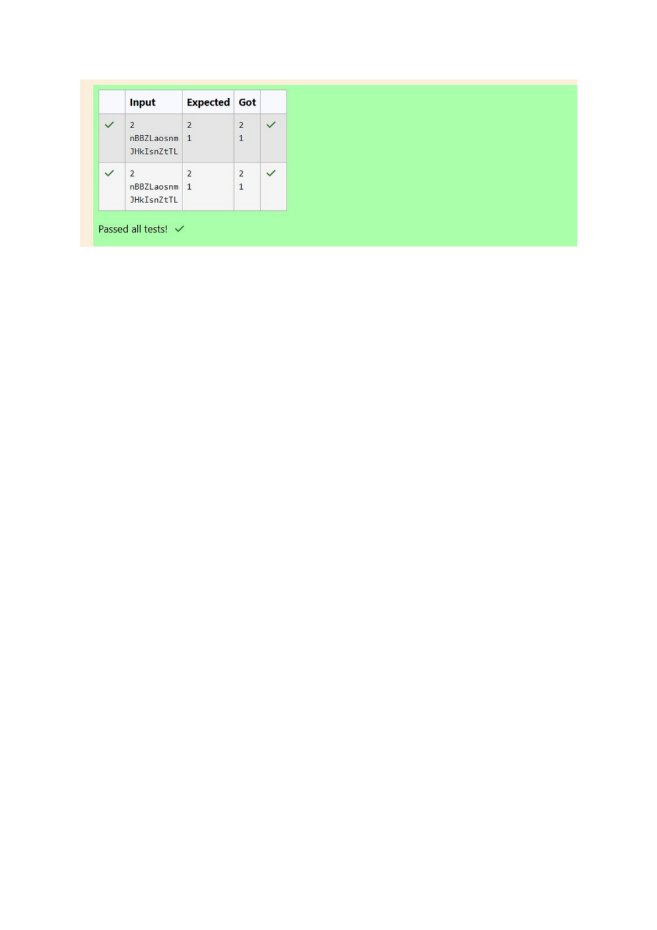

Q3) Given a sentence, s, print each word of the sentence in a new line.

Input Format

The first and only line contains a sentence, s.   
Constraints

1 ≤ len(s) ≤ 1000   
Output Format   
Print each word of the sentence in a new line.

Sample Input

This is C   
Sample Output

This

is

C

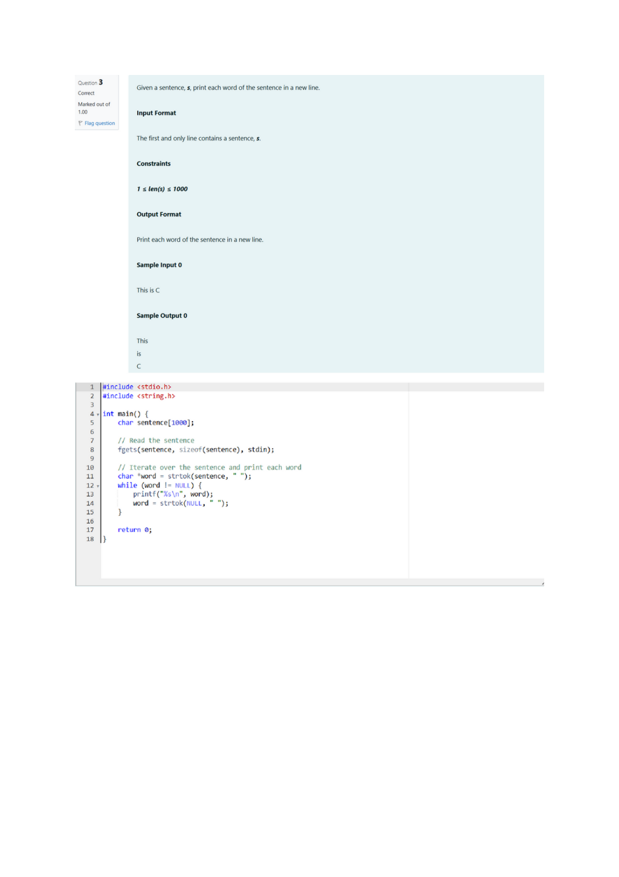

Output:

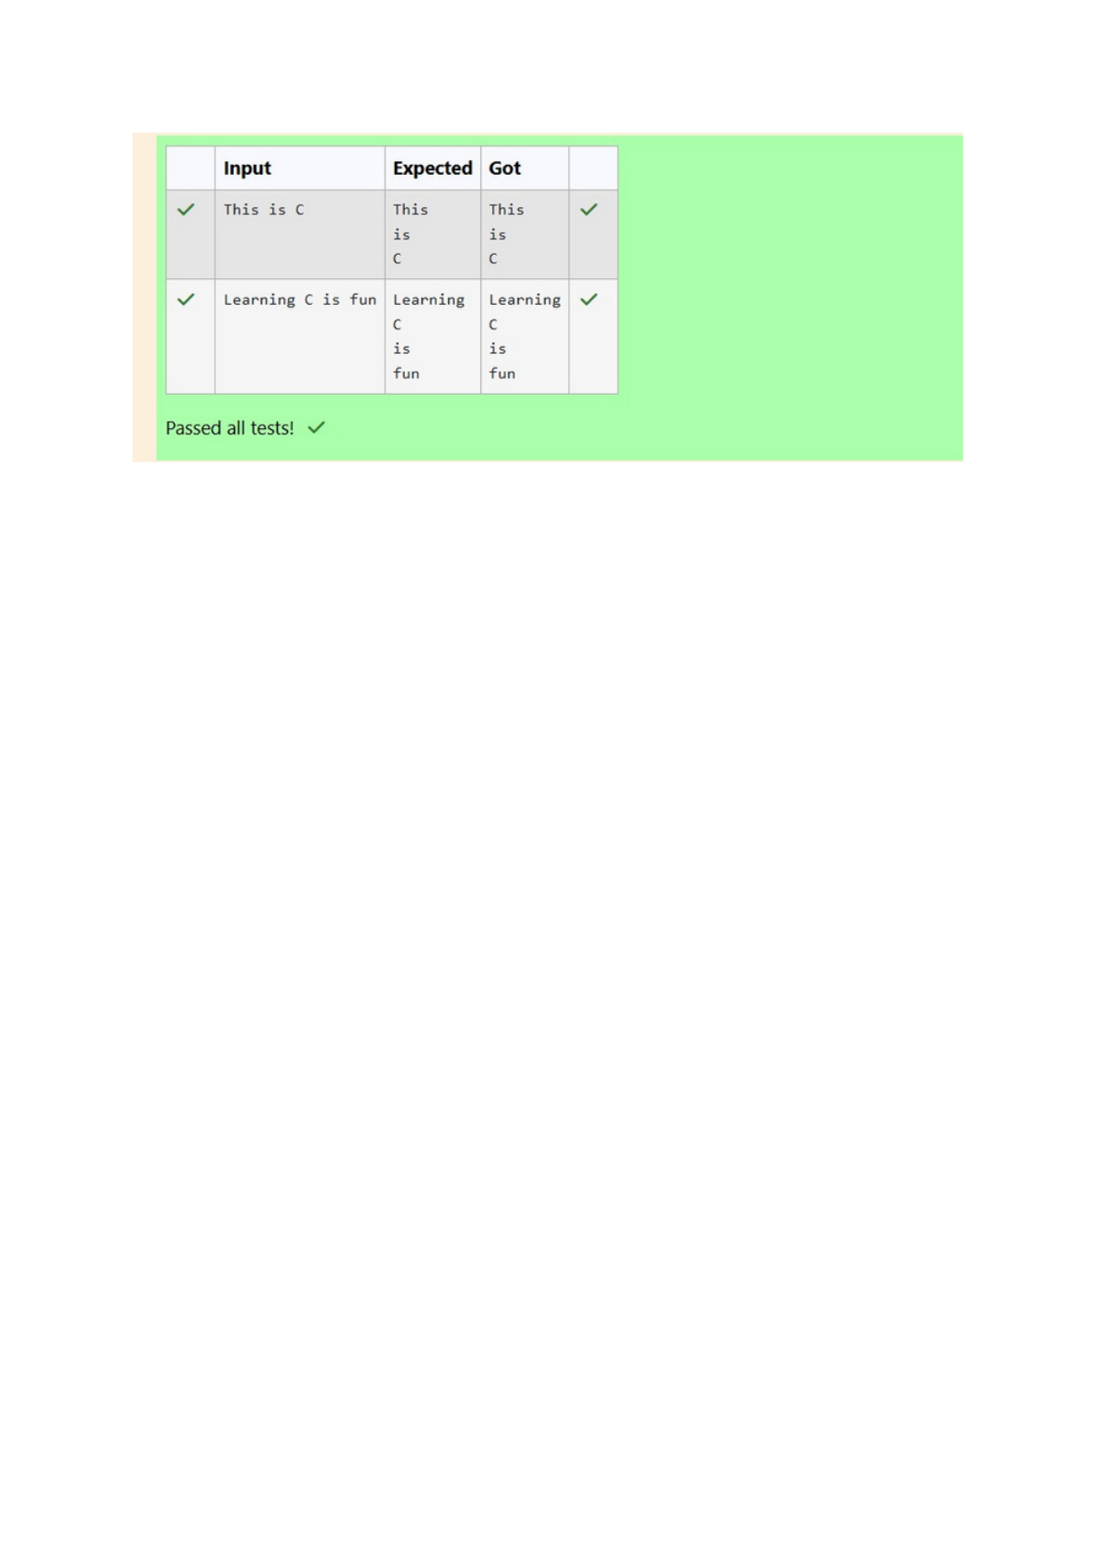

Q4) Input Format

You are given two strings, a and b, separated by a new line. Each string will consist of

lower-case Latin characters ('a'-'z').

Output Format

In the first line print two space-separated integers, representing the length of a and b

respectively.

In the second line print the string produced by concatenating a and b (a + b).

In the third line print two strings separated by a space, a' and b'. a' and b' are the same as

a and b, respectively, except that their first characters are swapped.

Sample Input

abcd

ef

Sample Output

4 2

abcdef

ebcd af

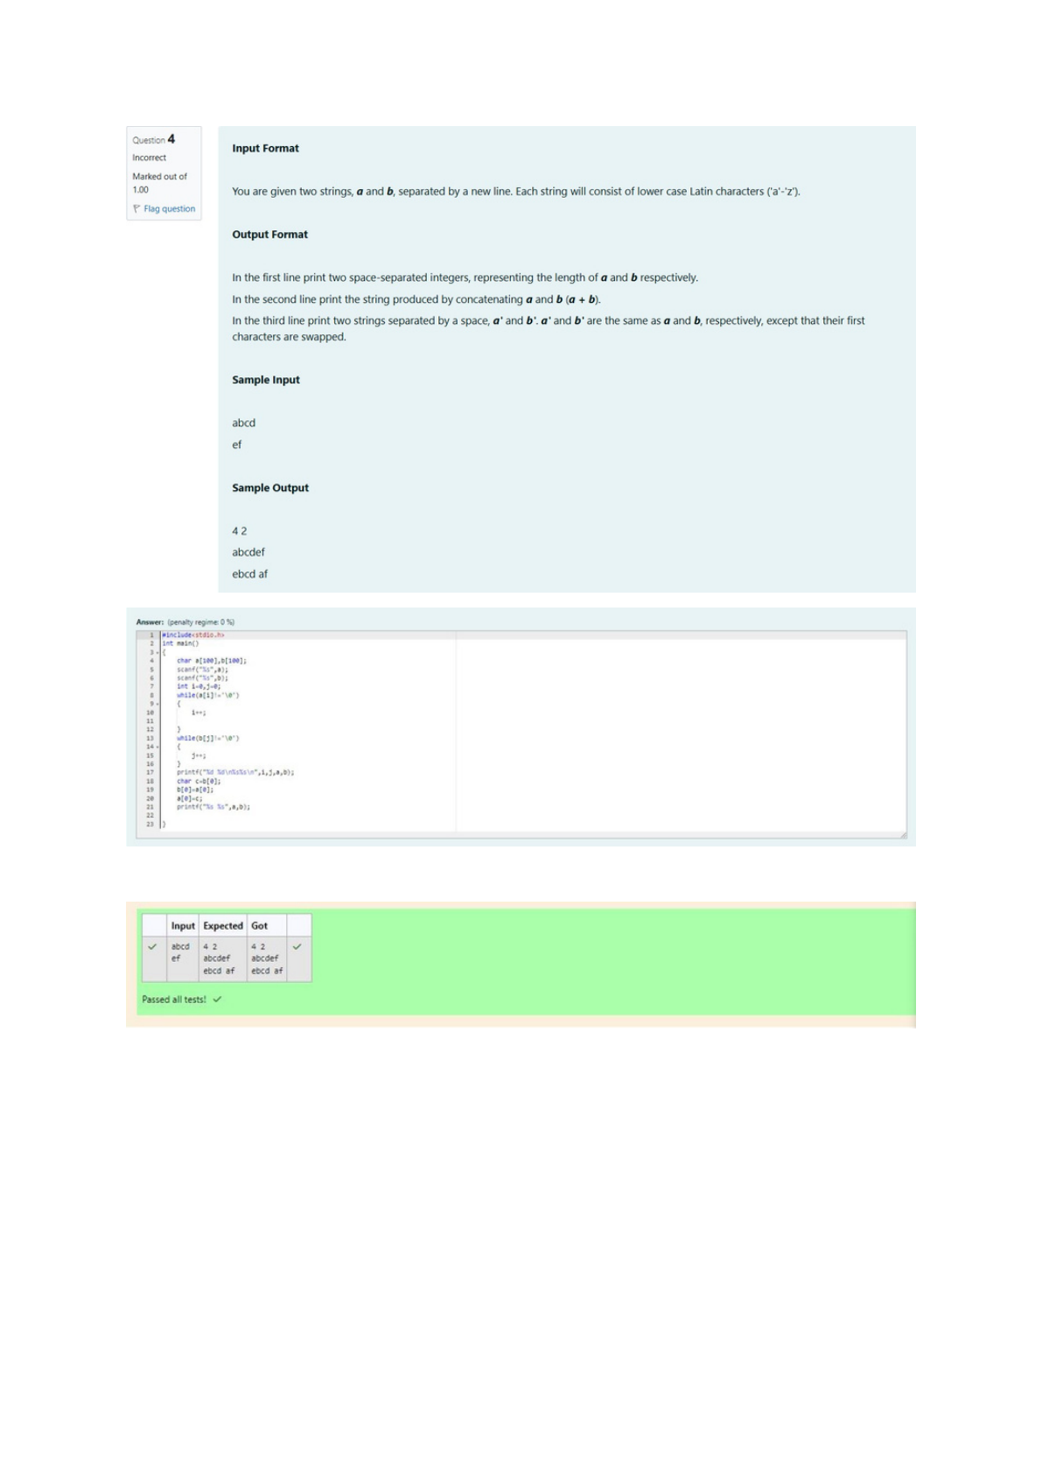

Output: